SIMATS ENGINEERING
ASSESSMENT TOOL 3

COURSE NAME: Database Management Systems COURSE CODE: CSA0504

COURSE OUTCOME COVERED

CO2: Apply the relational model, relational algebra, SQL query structures, and views to solve database querying and data manipulation problems. (BL3, BL6)

Activity Tool: Debugging & Optimisation Task (Low) Assessment Tool Weightage: 10%

QUESTIONS
Q.N  o | Question | Bloom's Level
1 | Identify and correct errors in a given SQL CREATE TABLE statement with incorrect syntax and missing constraints. | BL2 –  Understand
2 | Debug an SQL query that incorrectly uses aggregate functions without GROUP BY and fix the issue. Bloom’s Level: | BL2 –  Understand
3 | Correct a faulty SELECT query where column names are misspelled or improperly referenced. | BL1 –  Remember
4 | Fix errors in an SQL query using JOIN, where the join condition is missing or incorrect. | BL3 – Apply
5 | Identify and correct a subquery error where multiple values are returned instead of a single value. | BL2 –  Understand
6 | Debug a VIEW creation statement that contains invalid column references or syntax errors. | BL1 –  Remember
7 | Examine an SQL query with unnecessary conditions and optimize it by simplifying the WHERE clause. | BL3 – Apply
8 | Identify violations of integrity constraints in a given table and correct them. | BL2 –  Understand

9 | Fix a relation that violates 1NF or 2NF by removing repeating groups or partial dependencies. | BL3 – Apply
10 | Identify redundant attributes in a relation and apply basic normalization (up to 3NF) to improve design. | BL3 – Apply

Code of Conduct:

I Shaik Mansoor (192525010) certify that this submission is my original work and that I have adhered to the guidelines specified for this assessment. I understand that any violation of academic integrity rules will result in disciplinary action.

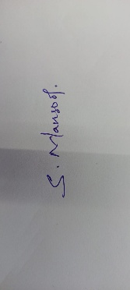

Signature of the student:

RUBRICS FOR CALCULATION:

Criteria | Level 4 (Exemplary) | Level 3 (Proficient) | Level 2 (Developing) | Level 1 (Beginning)
Problem Identification | Accurately identifies all errors and root causes with clear understanding | Identifies most errors with minor gaps | Identifies some errors but misses key issues | Unable to identify errors correctly
Debugging | Applies systematic debugging techniques effectively to  resolve issues | Uses appropriate debugging methods with minor errors | Limited debugging approach; requires guidance | Unable to debug or resolve issues
Optimization | Optimizes code by significantly improving time complexity using efficient algorithms | Improves time complexity with minor gaps in efficiency | Limited improvement in time complexity | No improvement; inefficient approach retained
Analysis | Demonstrates strong logical reasoning and clear justification of solutions | Shows reasonable analysis with some justification | Limited analysis; weak reasoning | No analytical reasoning demonstrated
Code Quality | Produces clean,  well-structure d code with proper comments and | Code is mostly clear with minor documentation gaps | Code lacks structure and proper documentation | Poorly written code with no documentation

- Create Table Debugging Incorrect code:
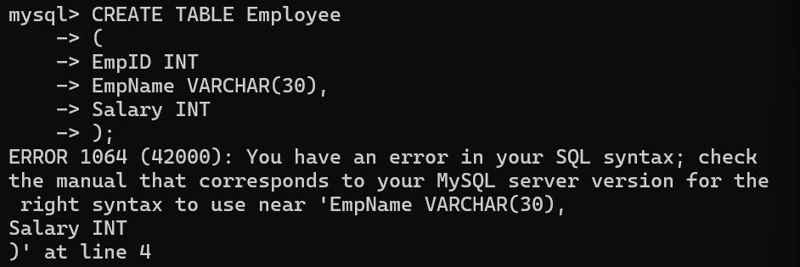
Error Identified:
  - The CREATE TABLE statement contained syntax errors and missing constraints such as PRIMARY KEY and NOT NULL.

Correct code:
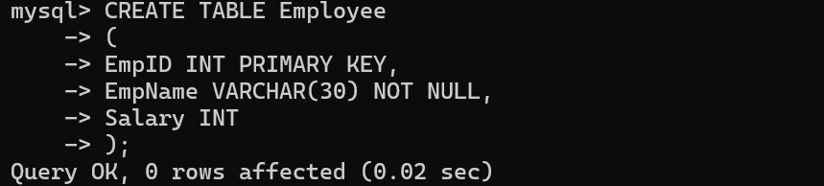
The syntax errors were fixed and the required constraints were added. The table was created successfully.

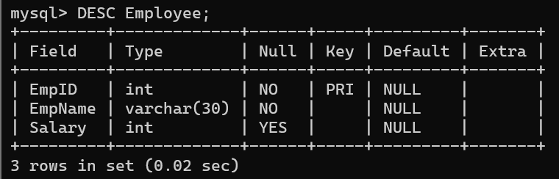

- Aggregate Function Debugging
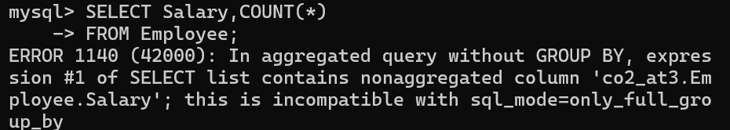
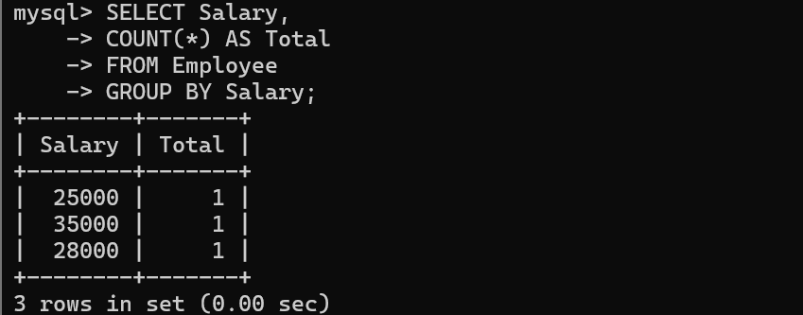

- Column Name Correction
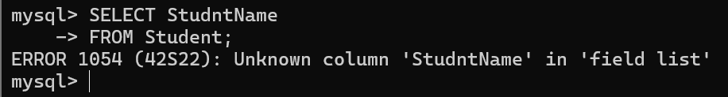
Incorrect Query:
The query contains a misspelled column name, causing an unknown column error.

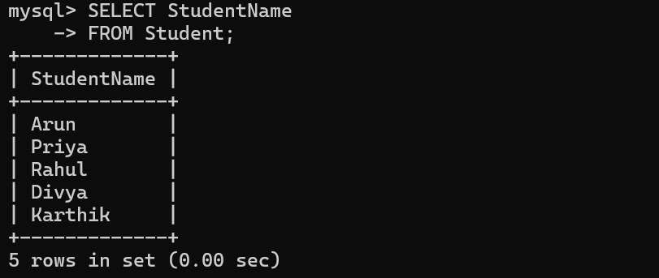
Corrected Query:
The column name was corrected, and the query executed successfully.

- JOIN Query Correction
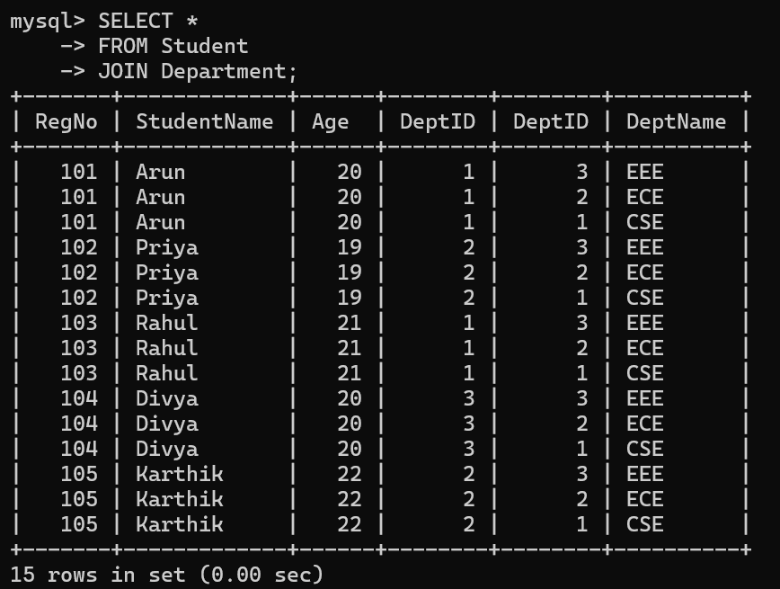
Incorrect Query:
The JOIN statement is missing the join condition, resulting in an incorrect query.

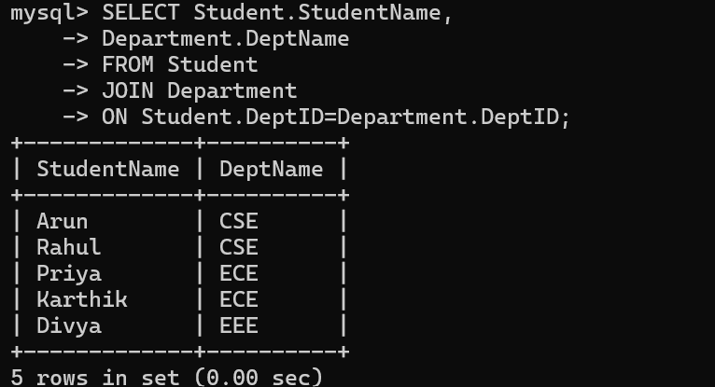
Corrected Query:
The correct ON condition was added, and the tables were joined successfully

- Subquery Correction
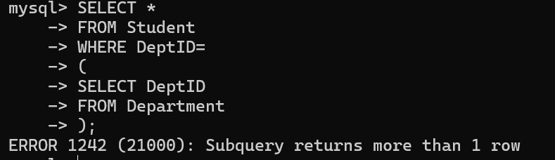
Incorrect Query:
The subquery returns multiple rows where only a single value is expected.
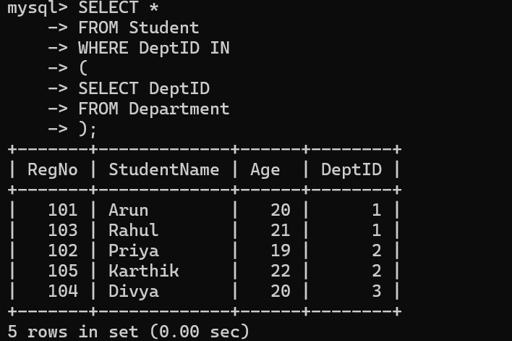

Corrected Query:
The IN operator was used to handle multiple values, and the query executed successfully.

- VIEW Debugging
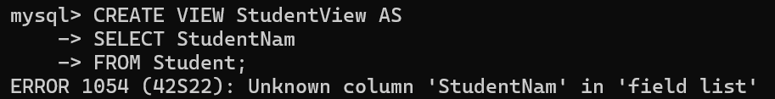
Incorrect Query:
The VIEW creation failed because the view already existed (or contained an invalid reference).
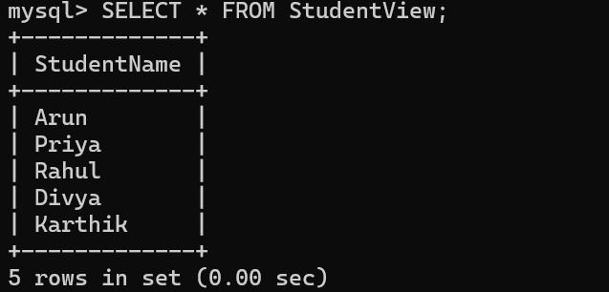
Corrected Query:
The existing view was removed and recreated successfully with the correct SQL statement.

- Query Optimization Original Query:
The query contains redundant conditions, making it unnecessarily complex.
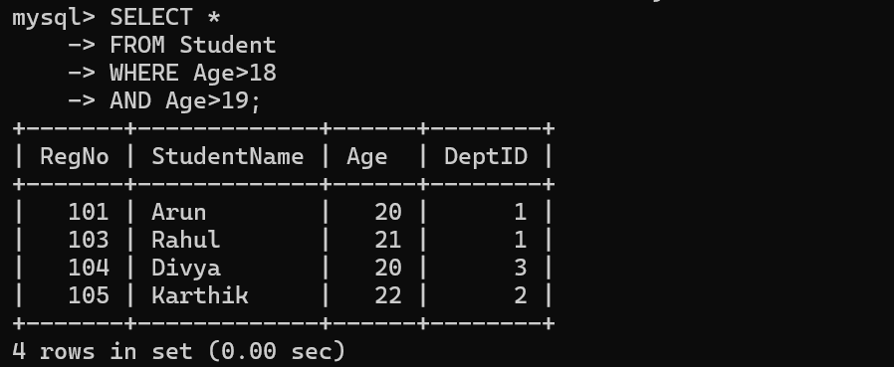
Optimized Query:
The redundant condition was removed, producing the same result with a simpler and more efficient query.

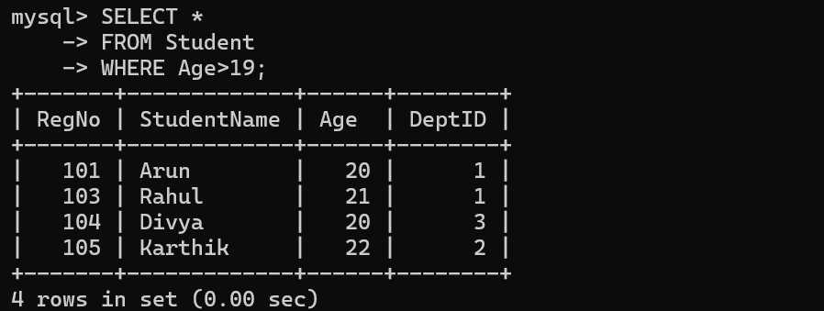
Same output, but the optimized query is simpler because it removes the redundant condition.

- Integrity Constraint Correction
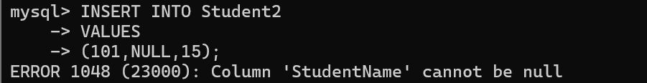
Incorrect Data:
The inserted data violates one or more integrity constraints, causing the insertion to fail.
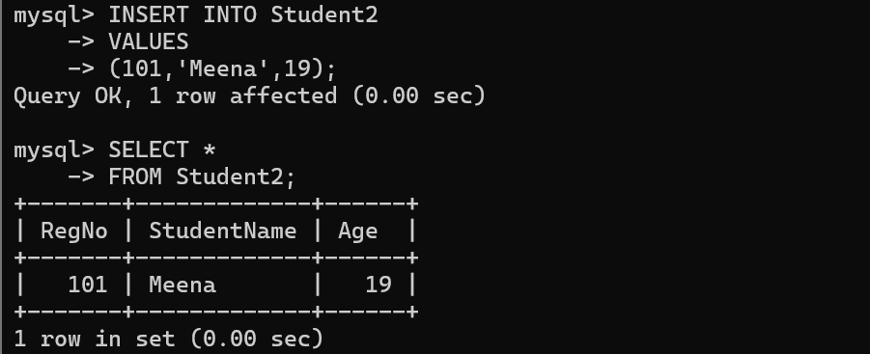
Corrected Data:
The data was modified to satisfy all integrity constraints and was inserted successfully.

- 1NF / 2NF Normalization
Original relation containing repeating groups (violates 1NF).

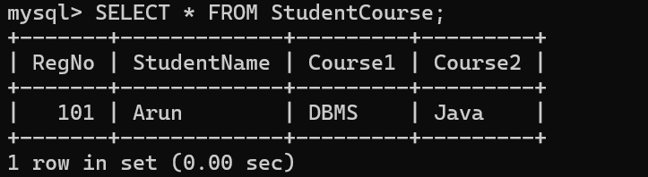
Creation of normalized tables.
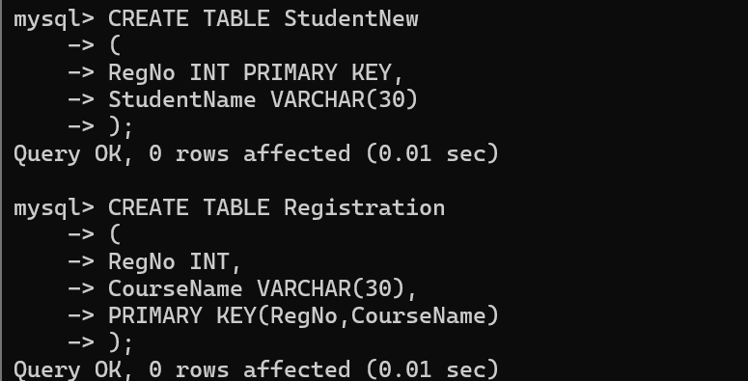

Data inserted into normalized tables.
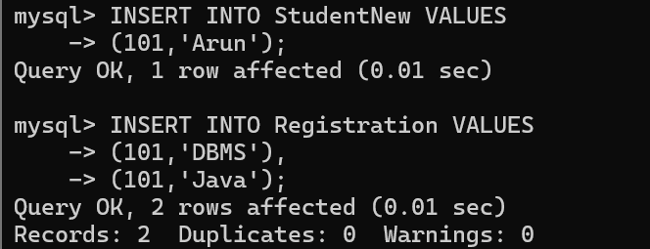

Normalized tables after removing repeating groups (1NF achieved)
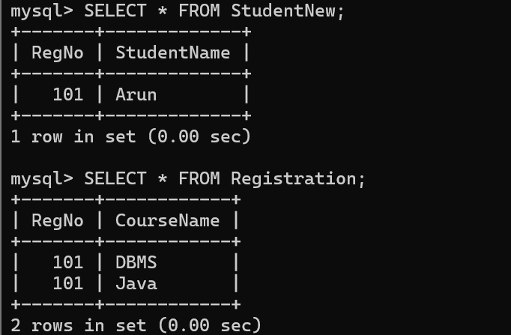
Original Relation:
The table contains repeating groups, violating the First Normal Form (1NF). Below Normalized Tables Screenshot
Normalized Relation:
The relation was decomposed into separate tables, eliminating repeating groups and improving data organization.

- 3NF Normalization
Creating the Department table to store department details separately.
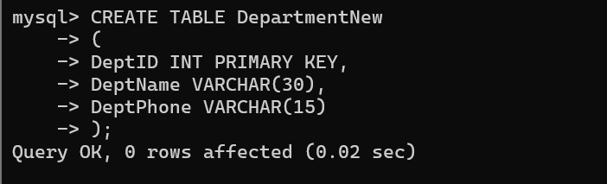

Creating the Student table with a foreign key reference.
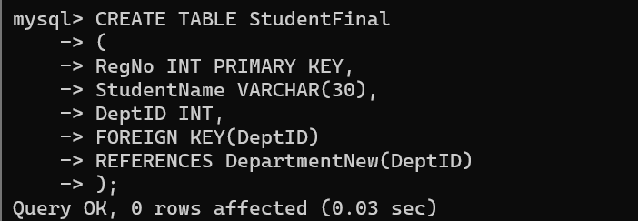

Inserting data into the normalized tables.
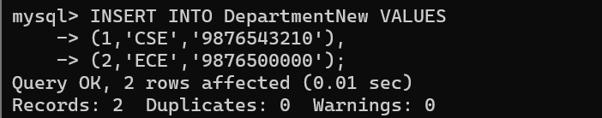
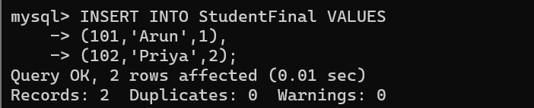

Normalized tables after applying Third Normal Form (3NF).
